# North-South-University-logo-03.png

CSE 299 Junior Design Project Report

# Topic: Obstacles Avoided Fire Fighting Car with Radar System

## Submitted To:

Md. Shahriar Hussain

Department of Electrical and Computer Engineering

North South University

## Submitted By:

Khadizatul Kubra – 1620070042

Mohammad Bin Khasru - 1321489042

Rafid Khan - 1520862642

Acknowledgement:

Firstly, we would like to thank Md. Shahriar Hussain, our honorable faculty of our course CSE299, North South University; for his guideline and feedback. Secondly, we pledge our gratitude towards North South University for providing necessary resources and special thanks to my group mates.

Index

1. Introduction -------------------------------------------------------------------------
2. Motivation ----------------------------------------------------------------------------
3. Theoretical Background -----------------------------------------------------------
4. Platform-------------------------------------------------------------------------------
5. Tools-----------------------------------------------------------------------------------
6. Result ----------------------------------------------------------------------------------
7. Cost-------------------------------------------------------------------------------------
8. Project Timeline ---------------------------------------------------------------------
9. Conclusion ----------------------------------------------------------------------------
10. Reference -----------------------------------------------------------------------------

# Introduction:

**Obstacle Avoiding Car with fire sensor** is an intelligent device, which can automatically sense the obstacle in front of it and avoid them by turning itself in another direction. This design allows the car to navigate in unknown environment by avoiding collisions, which is a primary requirement for any autonomous car. The application of Obstacle Avoiding car is not limited and it is used in most of the military organization now which helps carry out many risky jobs that cannot be done by any soldiers. We will use **Arduino and Ultrasonic Sensor to build an Obstacle Avoider.**Here an Ultrasonic sensor is used to sense the obstacles in the path by calculating the distance between the car and obstacle. If car finds any obstacle it changes the direction and continue moving. Normally obstacle avoidance is considered to be distinct from path planning where it is implemented as a reactive control law. The controller will guide the car after computing the pre computation of an obstacle free path

For detecting the obstacles, we will implement a radar system, which can detect any obstacles with its specified range. RADAR system is object detection or tracking system, which uses radio waves to decide or get the range, height, heading, or speed of items or objects. Radar frameworks or system arrive in an assortment of sizes and have distinctive performance particulars. Some radars are utilized for aviation authority at air terminals and others are utilized for long range observation and early cautioning frameworks Radar System controlled via Arduino. This RADAR system consists of an ultra-sonic sensor and servo motor, these are the major components of the system. Ultra-sonic sensor is attached to the servo motor.  
It rotates about 180 degree and gives visual representation on the software  
called processing IDE. Processing IDE gives graphical representation and it  
also gives angle or position of the object and distance of the object. Arduino UNO board is sufficed to control ultrasonic sensor and also to interface the sensor and display device. Main application of this RADAR system comes into different field of navigation, positioning, object identification, mapping, spying or tracking and different applications. These less investment systems are also suitable for indoor  
applications.

**Fire Detection:** For detecting the fire, we are using fire sensor at the front of the Board. This Fire sensor module pin is connected with the motor shield. Whenever the fire sensor detects any fire, the fire sensor will give the output volume high and the motor pump will on.

**Motor Pump:** Another motor pump is connected with the Arduino. Whenever the fire sensor detects any fire it will give the output to Arduino and Arduino will give the output to the pump as input. After that the pump will start.

# Motivation:

The main purpose of making this car is the car that has the capability of self-driving without any accidents. This car is able to move and not only detect the objects but also avoid them by itself.

An intelligent fire fighting car system is integrated by many functions and systems. One of the most important systems is the fire detection function in an intelligent home. The fire event may involve dangerous in life. There have been many deaths around the world because of fires. The deaths are especially rising as last year more than five hundred people were killed because of fires in Pakistan and Bangladesh. The deaths in the other countries might be less but it is still a worrying factor because as well as lives the amount of product, which is lost due to fire. Very few buildings have fire detectors and obstacle avoidance system because of their price and installation. Even if there are detectors installed the primitive technology that is used in the devices make them unreliable as because of false alarms and those which are free or are reliable they are priced at a very high range which is why they are often avoided .The fire detection device is fixed on the wall or ceiling .

The motivation towards working on this project was originated from the view of massive fire occurrence in Bangladesh and it is increasing rapidly day by day. The existing fire extinguishing system is working according to our needs but we wanted to establish an innovative idea and make more feasible and reliable system .Thus we can reduce losses than before and protect human life and property.

# Literature Review:

In the past literatures, many experts make project in the service. Some research addressed in developing target-tracking system of service robot such as Hisato Kobayashi et al. proposed a method to detect human being by an autonomous mobile guard robot .Yoichi Shimosasa et al. developed Autonomous Guard robot which integrate the security and service system to an Autonomous Guard robot, the robot can guide visitors in daytime and patrol in the night. D.A Ciccimaro developed the autonomous security robot “ROBOT III” which equipped with the non-lethal-response weapon .Moreover , some research addressed in the robot has the capability of extinguishing the fire .There are some products that have been published for security robot. Such as, SECON and SOC in Japanese and International Robotics in USA. Wang et al developed a multisensory fire detection algorithm using neural network.

Our project is divided into two parts –

• Software

• Hardware part

The fire detection and motor driver controlling is the software part and implementation, integration and application is the hardware part. As we are making a pumping system, we choose the fire detection system to detect fire. Fire sensor will help us to detect fire using a simple method. Because of its simplicity, this method of approach can be used in any number of ways on any type of camera.

**Software Design**

The software for the car was coded in Arduino IDE, because of compiler availability, our familiarity with the language, as well as the greater control of the system offered as compared to other higher languages.

# Hardware Part:

# Arduino Uno:

The Arduino Uno R3 is a microcontroller board based on a removable, dual-inline-package (DIP) ATmega328 AVR microcontroller. It has 20 digital input/output pins (of which 6 can be used as PWM outputs and 6 can be used as analog inputs). Programs can be loaded on to it from the easy-to-use Arduino computer program. The Arduino has an extensive support community, which makes it a very easy way to get started working with embedded electronics. The R3 is the third, and latest, revision of the Arduino Uno.

# Ultrasonic Sensor:

|  |  |  |
| --- | --- | --- |
| **Pin Category** | **Pin Name** | **Details** |
| Power | Vin, 3.3V, 5V, GND | Vin: Input voltage to Arduino when using an external power source.  5V: Regulated power supply used to power microcontroller and other components on the board.  3.3V: 3.3V supply generated by on-board voltage regulator. Maximum current draw is 50mA.  GND: ground pins. |
| Reset | Reset | Resets the microcontroller. |
| Analog Pins | A0 – A5 | Used to provide analog input in the range of 0-5V |
| Input/Output Pins | Digital Pins 0 - 13 | Can be used as input or output pins. |
| Serial | 0(Rx), 1(Tx) | Used to receive and transmit TTL serial data. |
| External Interrupts | 2, 3 | To trigger an interrupt. |
| PWM | 3, 5, 6, 9, 11 | Provides 8-bit PWM output. |
| SPI | 10 (SS), 11 (MOSI), 12 (MISO) and 13 (SCK) | Used for SPI communication. |
| Inbuilt LED | 13 | To turn on the inbuilt LED. |
| TWI | A4 (SDA), A5 (SCA) | Used for TWI communication. |
| AREF | AREF | To provide reference voltage for input voltage. |

# Pin Diagram:

# Arduino Uno Technical Specifications

|  |  |
| --- | --- |
| Microcontroller | [ATmega328P](https://components101.com/microcontrollers/atmega328p-pinout-features-datasheet) – 8 bit AVR family microcontroller |
| Operating Voltage | 5V |
| Recommended Input Voltage | 7-12V |
| Input Voltage Limits | 6-20V |
| Analog Input Pins | 6 (A0 – A5) |
| Digital I/O Pins | 14 (Out of which 6 provide PWM output) |
| DC Current on I/O Pins | 40 mA |
| DC Current on 3.3V Pin | 50 mA |
| Flash Memory | 32 KB (0.5 KB is used for Bootloader) |
| SRAM | 2 KB |
| EEPROM | 1 KB |
| Frequency (Clock Speed) | 16 MHz |

### Overview

**Arduino Uno** is a microcontroller board based on 8-bit ATmega328P microcontroller. Along with ATmega328P, it consists other components such as crystal oscillator, serial communication, voltage regulator, etc. to support the microcontroller. Arduino Uno has 14 digital input/output pins (out of which 6 can be used as PWM outputs), 6 analog input pins, a USB connection, A Power barrel jack, an ICSP header and a reset button.

### How to use Arduino Board

The 14 digital input/output pins can be used as input or output pins by using pinMode(), digitalRead() and digitalWrite() functions in arduino programming. Each pin operate at 5V and can provide or receive a maximum of 40mA current, and has an internal pull-up resistor of 20-50 KOhms which are disconnected by default.  Out of these 14 pins, some pins have specific functions as listed below:

* **Serial Pins 0 (Rx) and 1 (Tx):** Rx and Tx pins are used to receive and transmit TTL serial data. They are connected with the corresponding ATmega328P USB to TTL serial chip.
* **External Interrupt Pins 2 and 3:** These pins can be configured to trigger an interrupt on a low value, a rising or falling edge, or a change in value.
* **PWM Pins 3, 5, 6, 9 and 11:** These pins provide an 8-bit PWM output by using analogWrite() function.
* **SPI Pins 10 (SS), 11 (MOSI), 12 (MISO) and 13 (SCK):** These pins are used for SPI communication.
* **In-built LED Pin 13:** This pin is connected with an built-in LED, when pin 13 is HIGH – LED is on and when pin 13 is LOW, it’s off.

Along with 14 Digital pins, there are 6 analog input pins, each of which provide 10 bits of resolution, i.e. 1024 different values. They measure from 0 to 5 volts but this limit can be increased by using AREF pin with analog Reference () function.

* Analog pin 4 (SDA) and pin 5 (SCA) also used for TWI communication using Wire library.

Arduino Uno has a couple of other pins as explained below:

* **AREF:** Used to provide reference voltage for analog inputs with analogReference() function.
* **Reset Pin:**Making this pin LOW, resets the microcontroller.



# Communication

Arduino can be used to communicate with a computer, another Arduino board or other microcontrollers. The ATmega328P microcontroller provides UART TTL (5V) serial communication which can be done using digital pin 0 (Rx) and digital pin 1 (Tx). An ATmega16U2 on the board channels this serial communication over USB and appears as a virtual com port to software on the computer. The ATmega16U2 firmware uses the standard USB COM drivers, and no external driver is needed. However, on Windows, a .inf file is required. The Arduino software includes a serial monitor which allows simple textual data to be sent to and from the Arduino board. There are two RX and TX LEDs on the arduino board which will flash when data is being transmitted via the USB-to-serial chip and USB connection to the computer (not for serial communication on pins 0 and 1). A SoftwareSerial library allows for serial communication on any of the Uno's digital pins. The ATmega328P also supports I2C (TWI) and SPI communication. The Arduino software includes a Wire library to simplify use of the I2C bus.

### Software

Arduino IDE (Integrated Development Environment) is required to program the Arduino Uno board.

### 

### Programming Arduino

Once arduino IDE is installed on the computer, connect the board with computer using USB cable. Now open the arduino IDE and choose the correct board by selecting Tools>Boards>Arduino/Genuino Uno, and choose the correct Port by selecting Tools>Port. Arduino Uno is programmed using Arduino programming language based on Wiring. To get it started with Arduino Uno board and blink the built-in LED, load the example code by selecting Files>Examples>Basics>Blink. Once the example code (also shown below) is loaded into your IDE, click on the ‘upload’ button given on the top bar. Once the upload is finished, you should see the Arduino’s built-in LED blinking.  Below is the example code for blinking:

// the setup function runs once when you press reset or power the board

void setup() {

// initialize digital pin LED_BUILTIN as an output.

pinMode(LED_BUILTIN, OUTPUT);

}

// the loop function runs over and over again forever

void loop() {

digitalWrite(LED_BUILTIN, HIGH); // turn the LED on (HIGH is the voltage level)

delay(1000); // wait for a second

digitalWrite(LED_BUILTIN, LOW); // turn the LED off by making the voltage LOW

delay(1000); // wait for a second

}

.

## Motor Shield:

A shield in Arduino terms is a circuit board, which coincides and fits perfectly with a basic Arduino board in order to serve a specific purpose. In this system, a motor shield has been used. A motor shield enables and Arduino Uno or Mega to run multiple motors at the same time. The motors can be in the form of stepper, servo or dc. A dc and a servo motor have been used in the system.



# Servo Motor:

Inside a servo motor, there are a smallDC motor, potentiometer, and a control circuit. The motor is attach to the board.

The servo motor in this project operates on 6V. Servo motors are mainly used for armature movement. The servo serves as a means of moving the supporting structure vertically with precision. The speed of servo motor can be varied. The speed of the motor can be controlled by providing consecutive pauses. A pause of hundred milliseconds was chosen after each degree movement of the motor.

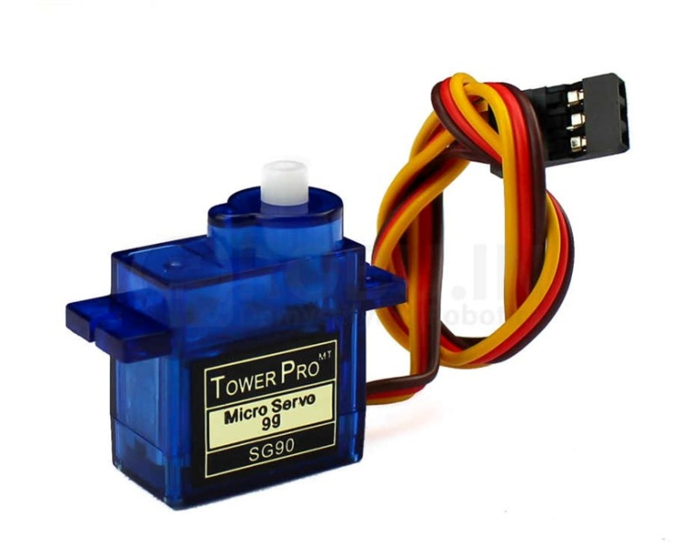

# Fire Sensor:

# Timeline:

To build up the project we need nearly 2 months.

# Tools Platform:

Tools list of the project is given below

* Arduino IDE
* Arduino Uno
* 2 Ultrasonic Sensors
* 4 Wheels
* 4 motors
* Servo motor
* Arduino Uno shield
* Motor shield Stepper motor
* Motor Shield
* Jumper Wires
* Breadbroad
* External Power Source/Battery
* Fire sensor
* Pump
* Water Can
* Pipe

# Circuit Diagram:

Circuit diagram for Obstacles Avoided Car

# Image result for obstacle avoiding car using arduino circuit diagram

Diagram for Object Detect Radar System

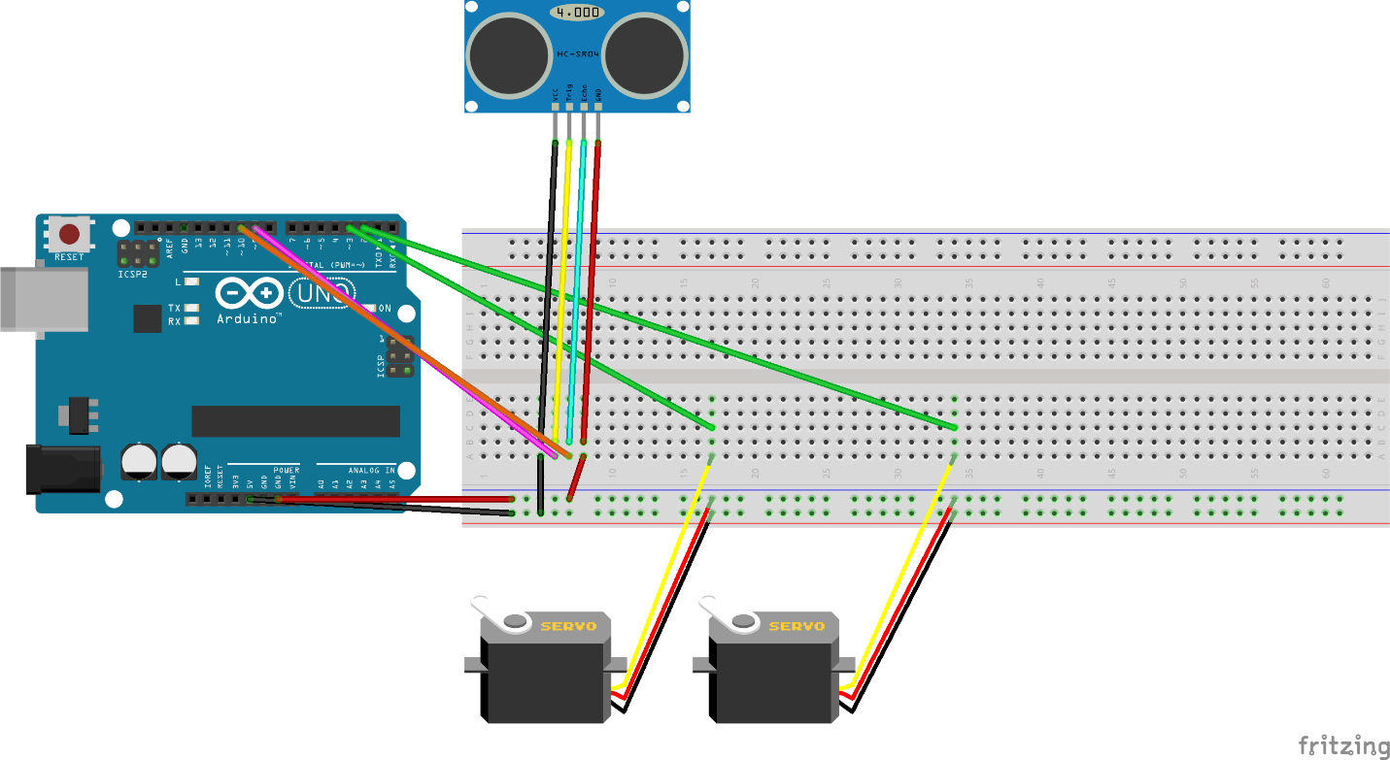

# Approximate Cost Unit:

The cost of the project can not be fixed. Because When doing the project some component might be damaged or not function properly. But we make a basic cost of the project.

Obstacles Avoided Car Cost - 2000-2500 taka

Object Detected Radar - 1500-2000 taka

So the total cost of the project is approximately 3500 to 4500 taka.

# Conclusion:

In our daily life, whether it’s an industry or domestic, the most common and fatal accidents occurred are due to fire. This results in both human loss and property loss. Fires claim the lives of innocent people around the world every single day. A small amount of fire is able to damage a huge part of a society. Although fire sensors and fire alarms alert people of danger, they often have few choices other than escaping from a building and calling the fire department. Although waiting for fire fighters to rescue people may not always be the best choice. The modern day home and business should be equipped with at least one fire extinguisher. Using modern fire extinguisher is not so easy and only a professional user can use it. Fire fighting obstacle avoidance car is a highly technical profession, which needs a lot of training and education to become a professional. So using the fire extinguisher is not at all suitable for people’s residence. For those purpose automated fire fighting obstacle avoidance car will be the best choice. It will save a lot of life by put off the fire spraying water on it.

# Reference:

1. Arduino Uno, http://arduino.cc/en/Main/arduinoBoardUno.
2. Motor shield, http://www.ladyada.net/make/mshield/ .
3. Chapman S., Electric Machinery Fundamentals, 2005, McGraw Hill
4. How servo motors work, http://www.jameco.com/Jameco/workshop/howitworks/how-servo-motors-work.html?sp_rid=MjkxOTAwODE2NjQS1&sp_mid=4334065 .
5. Anis Ahmed & Ruma Paul "More than 100 die in garment factory fire, the deadliest in Bangladesh's history". The Christian Science Monitor. Archived from the original on 25 November 2012.Retrived 3 may 2013